Deep Learning Performance metrics on HAR with Wearable Sensor (Mobile) on UCI dataset
METRIC | LSTM | BILSTM | GRS-BILSTM | MS-GRS-BILSTM
PRECISION | 0.8285 | 0.8771 | 0.9172 | 0.9585
RECALL | 0.8047 | 0.8692 | 0.9128 | 0.9570
F1-SCORE | 0.7963 | 0.8698 | 0.9138 | 0.9576
TEST ACCURACY | 0.8093 | 0.8697 | 0.9128 | 0.9576
TEST LOSS | 0.7685 | 0.4444 | 0.3096 | 0.3958
COHEN’S KAPPA | 0.7703 | 0.8433 | 0.8952 | 0.9490
MATTHEWS CORR. COEF (MCC) | 0.7783 | 0.8448 | 0.8957 | 0.9491
MODEL PARAMETERS | 12,471 | 10,423 | 43,271 | 1,342,109
MODEL SIZE | 0.1607 MB | 0.1410 MB | 0.5267 MB | 15.4460 MB
AVG BATCH INFERENCE TIME | 0.81 ms | 1.48 ms | 1.10 ms | 2.10 ms
SINGLE SAMPLE INFERENCE TIME | 0.0126 ms | 0.0231 ms | 0.0086 ms | 0.0328 ms
THROUGHPUT | 79,342 samples/sec | 43,360 samples/sec | 116,028 samples/sec | 30,463 samples/sec

Confusion Matrix
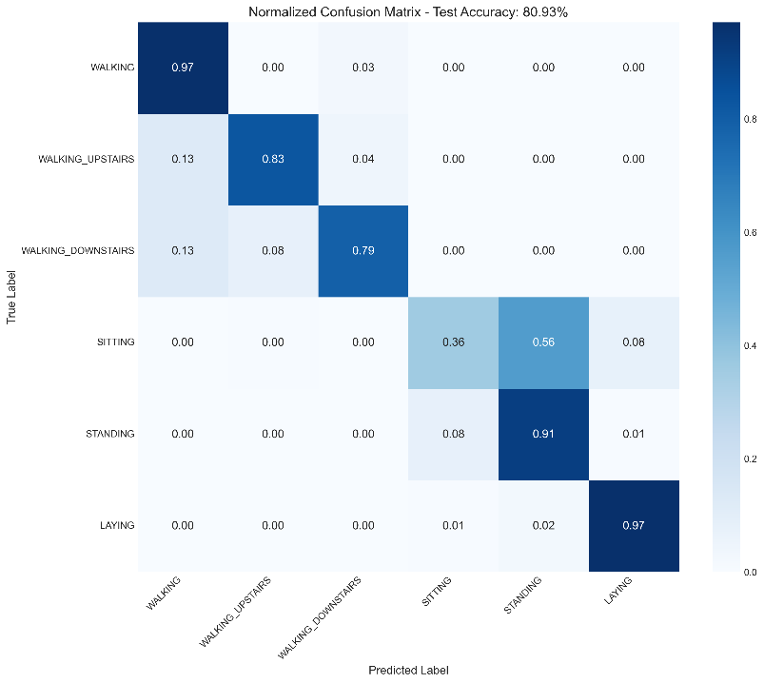 | 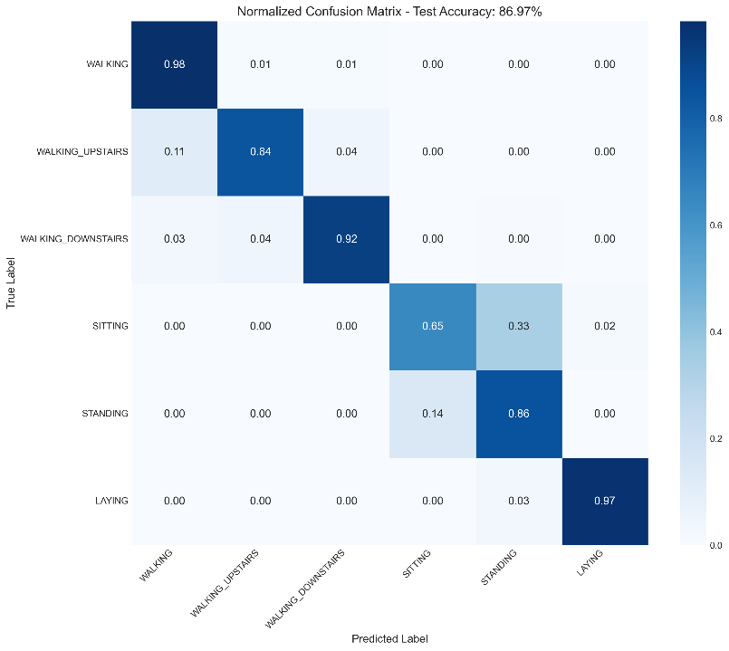
LSTM | BiLSTM
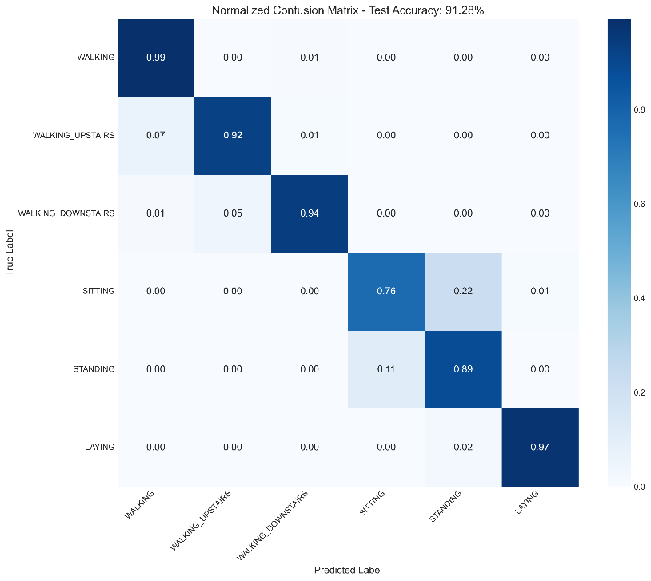 | 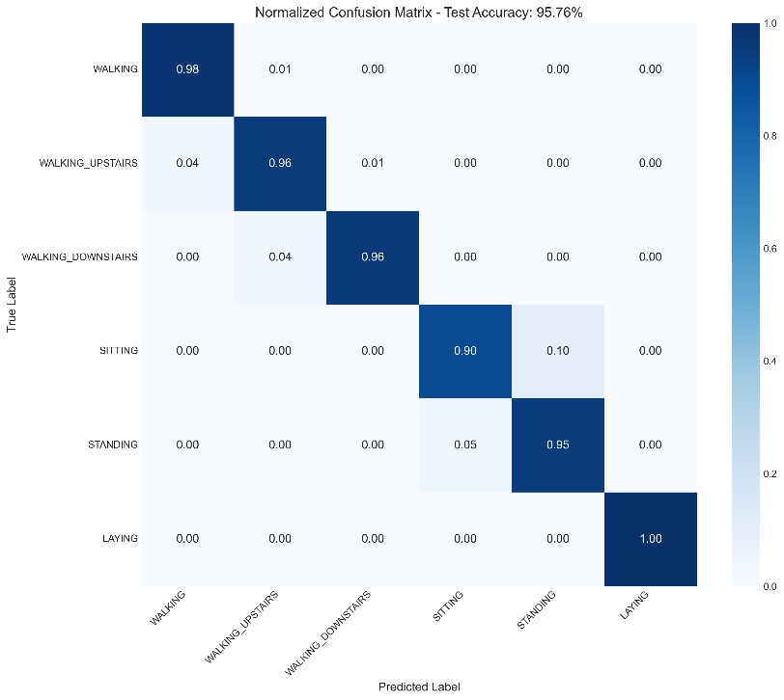
GRS-BiLSTM | MS-GRS-BiLSTM

Accuracy Loss Curve
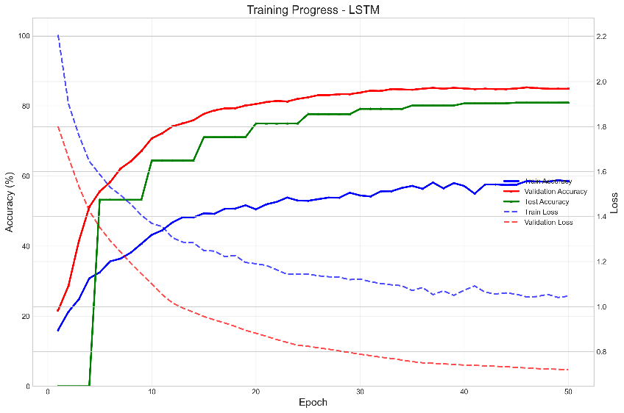 | 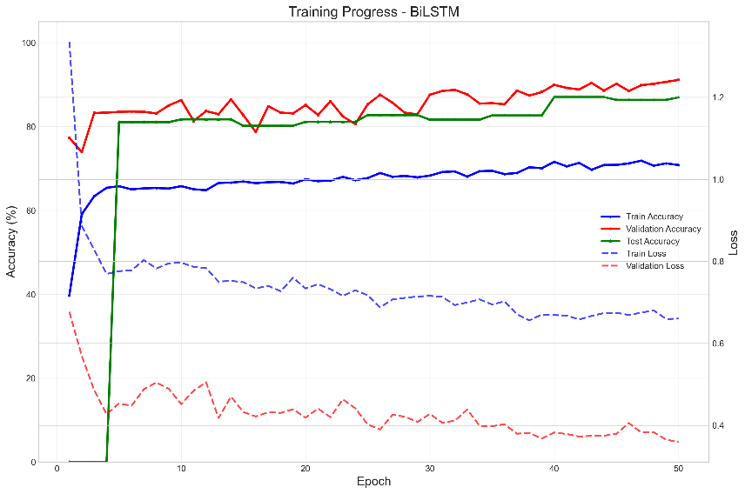
LSTM | BiLSTM
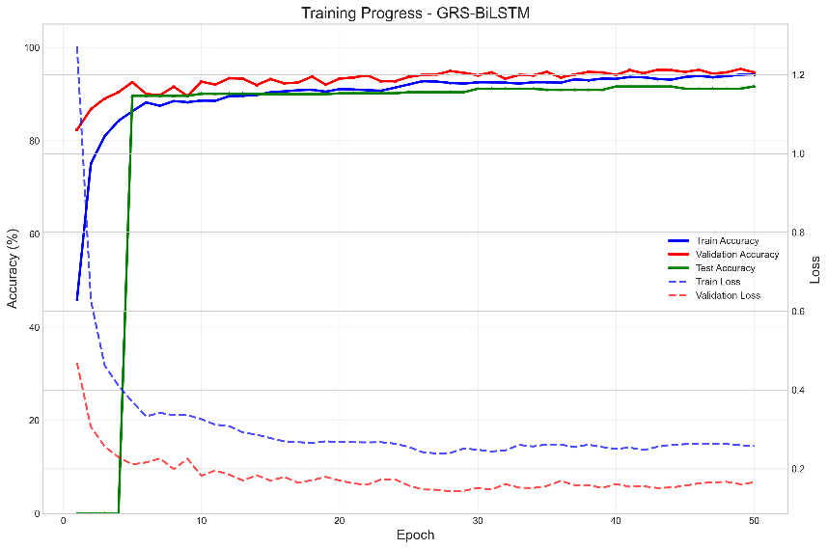 | 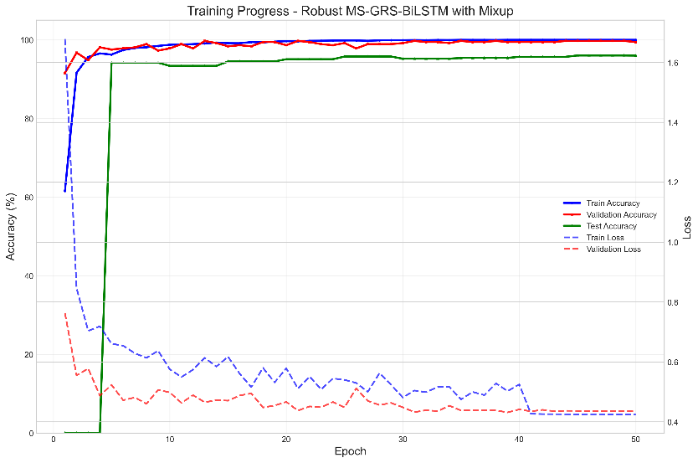
GRS-BiLSTM | MS-GRS-BiLSTM

